Solar Battery

Plan
In the planning stage, we lay out our plan on how we approached the project noting any issues that we had to overcome. This includes our drawn-out idea and then our simulation in LTSpice.
Our battery circuit consists of three stages.
These include the:
- Energy harvesting stage
- Charge management stage
- Power delivery stage
Below, we expand on each stage noting what they entail and how we simulated them.

1. Energy harvesting stage

Aim
To provide a stabilised voltage to the rest of the circuit from the solar panel without back charge at night.

Circuit
We use the following components
- A 5-volt solar panel
- A diode
- A capacitor
The solar panel was chosen with a value of 5 volts. This is due to the requirement of having a voltage above the usual voltage of the battery. Since the battery is around 3.2 to 3.4 volts, 5 volts provides us with a good overhead, that allows current to flow into the battery even when it reaches full capacity, in addition to the voltage drops across the diode and resistor.
At night the battery would allow the current to flow backwards, charging the solar panel. To prevent this, we add a Schottky diode to prevent the backflow of current.
The voltage from the solar panel would not be a steady 5 volts, but rather fluctuate around 5 volts, so we add a capacitor in series to stabilise the voltage.
Our preliminary drawing can be found in Figure 1.
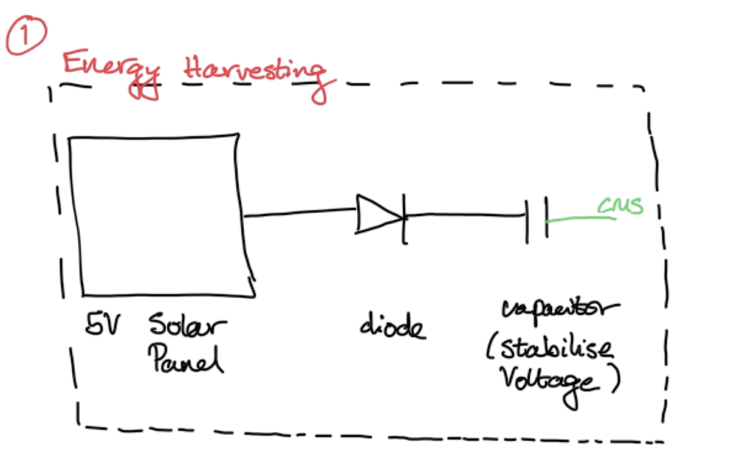
Figure 1

Simulation
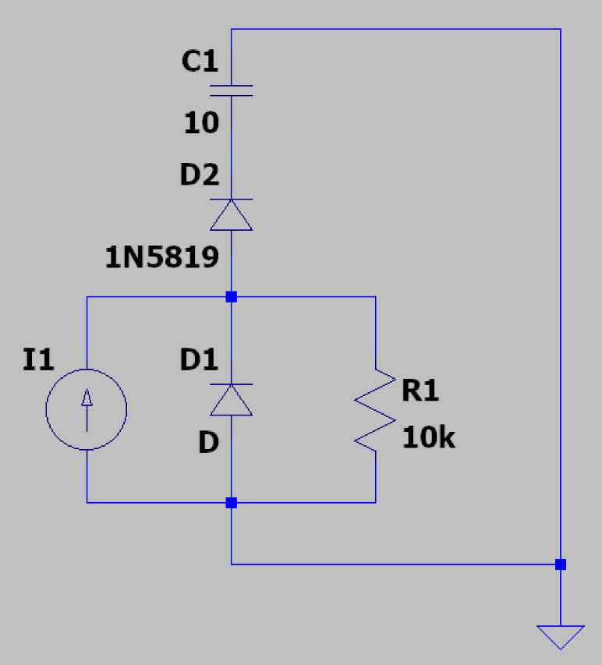
LTSpice does not have a solar panel, so we must use a current source, a resistor and 12 diodes, all in parallel to simulate it.
To test this section, we added a capacitor in series to act as the battery with a value of 10 Farads, so we were able to see it charge on a graph.
D1 represents 12 diodes, which we did by using a SPICE directive:
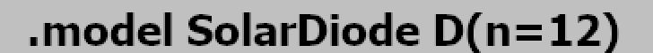

Testing the diode required us to vary the current source, to represent day and night. We used the following parameters, where the current source varied between 0 and 1.1 volts rising and falling every 10 seconds, with one period taking 100 seconds.


Simulating this over 100 seconds,
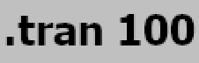
provided us with the following results:

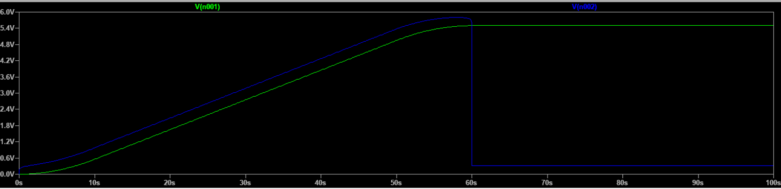
The circuit used in LTSpice for the Energy Harvesting stage.
Figure 2:
The green line represents the voltage at n001, the node entering the capacitor (C1), and the blue line represents the voltage at n002, the node leaving the current source (I1).
The graph shows two stages: “day”, when the current source outputs 1.1 A to represent sunlight, and “night”, when it drops to 0 A, representing no illumination.
In the first stage, we see a linear increase in the charge across the capacitor following the equation
$i=C \frac{dv}{dt}$, from which we can deduce the capacitor is being charged at a rate of 0.11 $V/s$. We also see a linear increase in the voltage provided from the current source; however, this rises to 6.0 volts. This difference between the source voltage and the capacitor voltage, can be described by the combined voltage drop across the diodes and resistor.
In the second stage, the current source drops to 0 volts instantly, to simulate the lack of sunlight. The capacitor would discharge back through the solar panel, but the diode (D2) stops it, and thus we see the voltage across the capacitor retaining its value of 5.5 volts. This is our desired output, so we consider the simulation of this stage a success.

However, a major difference between our circuit and the simulation is in the way the capacitor charges as opposed to our battery. In the simulation, we use a capacitor, which allows the voltage to climb to 5.5 volts without issue. The battery that we will use, will cap at around 3.6 volts and providing the extra 2 volts from the current source will damage it. This can be prevented by a charge controller, which leads us on to our next stage.

2. Charge management stage

Aim
To ensure the battery receives a maximum voltage at around 3.6 volts, to prevent overcharge.

Circuit
We use the following components
- A MCP73123 controller
- A LiFePo₄ battery
- A 1.1k ohm resistor
The controller was chosen due to its ability to handle around 1 amp of charging current with a protection against an overvoltage of 6.5 volts, able to operate from -40°C to +85°C in a small package. This provides us with enough overhead over the maximum of 5 volts from the solar panel and allows us to operate even in hot conditions. The controller’s job is to protect the battery. It does this in several ways:
- It has a CC-CV charge profile. When the battery is low, it enters CC mode, where the controller provides a steady amount of current to quickly charge. Once the battery has reached its regulation voltage (the maximum safe operating voltage), the controller enters CV mode, holds the voltage and begins to taper the current down. Finally, once the current drops below a threshold, the controller stops the charging process to prevent overcharge.
- It has an overvoltage protection where it will shut itself down, a thermal regulator to reduce charge current to lower the temperature and if the battery is deeply discharged, it uses a small current to safely allow the battery where it can handle full power.
- We can set the amount of current flowing into the battery by using a single external resistor on the PROG pin – 1.1 kilo ohm resistor in our case providing us with 909mA charge current.

The battery was chosen because of its increased safety over the alternatives, its ability to last for around 3500 cycles, providing us with the guarantee of the battery lasting at least 5 years. The voltage has very little fluctuations and stays at around 3.2 to 3.3 volts, without rapidly dropping. In an environmental sense, the battery does not contain cobalt, which is more toxic to the environment, and the materials used are more abundant and easier to remove at the end.

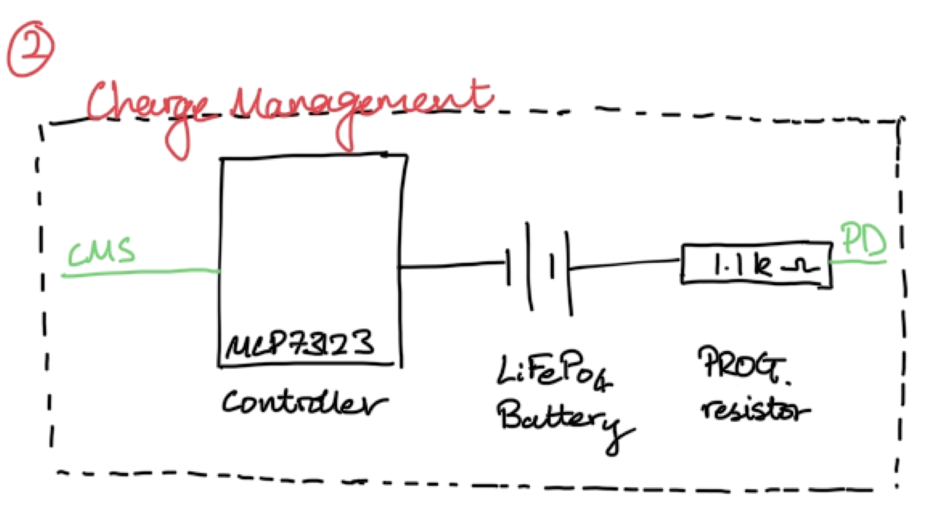

Simulation
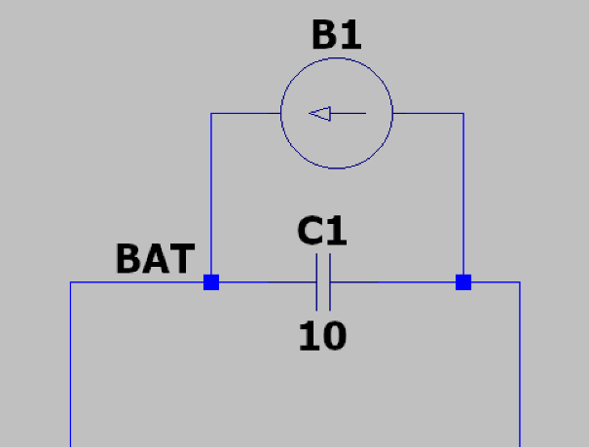
LTSpice does not have an inbuilt MCP73123 controller, so we use a current source to model it. We stick with the capacitor to model the battery and label the node connecting the Energy Harvesting stage to this stage, BAT. We do not modify the value of the capacitor or the resistor which was added in the previous stage
We model the current source with the following parameters:

This tells the source to allow a voltage lower than 3.55 through, but once 3.55 is reached, slowly taper down the current, imitating our controller.
The circuit used in LTSpice for the Charge
Figure 3:
_{Management stage}
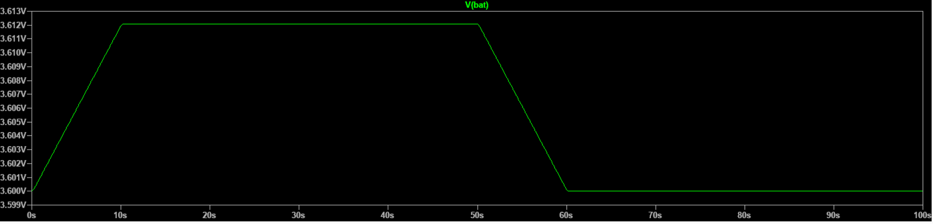
Simulating this provided us with the above graph where we can see the voltage at the BAT node vary over a period of 100 seconds, 50 seconds of day and 50 seconds of night.
From 0 to 10 seconds, we can see the full charge being pushed through, charging the battery. We are interested in the rest of the time, however. At 10 to 50 seconds, the voltage flattens out at 3.612 $V$. The controller sensed that the battery had reached its maximum capacity, so “capped” the voltage to prevent any overcharging.
From 50 to 60 seconds, the solar panel turns off to simulate night, and the voltage drops slightly as the "surface charge" disappears and the battery settles at its resting full state of 3.6 $V$.
Our diode works as expected preventing the battery from discharging back into the solar panel, so the battery stays at 3.6 $V$ for the remainder of the time.

However, our phone is unable to charge with such a low voltage, it requires a constant 5 $V$. We aim to fix this issue by using a boost converter which we implement in the following stage.

3. Power Delivery stage

Aim
To step-up the voltage from 3.6 volts to 5 volts to charge the device.

Circuit
We use the following component:
- A MT3608 boost converter
The converter boosts the input voltage provided from the solar battery to a stable 5 volts, at a voltage which would be accepted by the device.



